Add new module and prepare delivery

Document Revision History

|  |  |  |  |
| --- | --- | --- | --- |
| Revision | Date | By | Remarks |
| 1 | 2014-12-17 | Gananathan Kanapathipillai | Created |
| 2 | 2015-07-30 | Gananathan Kanapathipillai | Modified section 9 - To address missing .cre files entries in install.tem (related to Apps 9 build) |

1. Check the Sales Order 2

2. Generate Components 3

1.1 Pre-requisite check 3

1.2 Adding components to internal customer installations: 5

3. Generate .cifx file 6

4. Generate Config File 7

5. Fetch the required files 8

6. Remove unnecessary lng and trs files 9

7. eBOD information 10

8. Applying relavant bug corrections 11

9. Build and Install components 13

# Check the Sales Order

Whenever you receive a request to add any new components to an existing project, first you should check whether the relevant Module is already added to the Sales Order. Otherwise contact the relevant TPM and request them to make arrangements to add the relevant Module to the Sales Order.

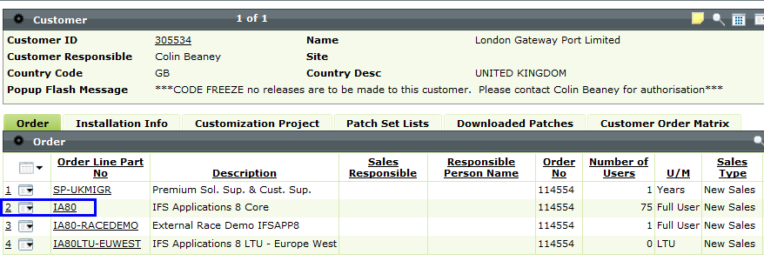

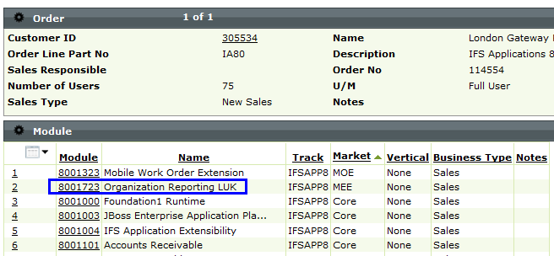

# Generate Components

## Pre-requisite check

Before adding the new components to an internal customer installation, it is worth making sure that you are aware of all the new components that you are about to add. Sometimes previous additions may not have been properly registered against the installations.

One way to do this is to generate a dummy installation and compare it with the existing installation.

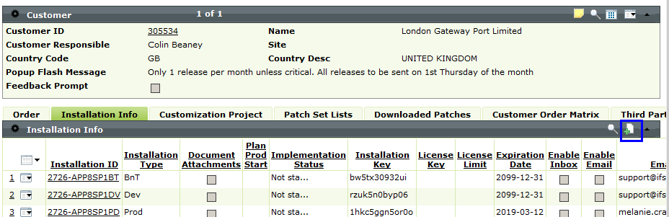

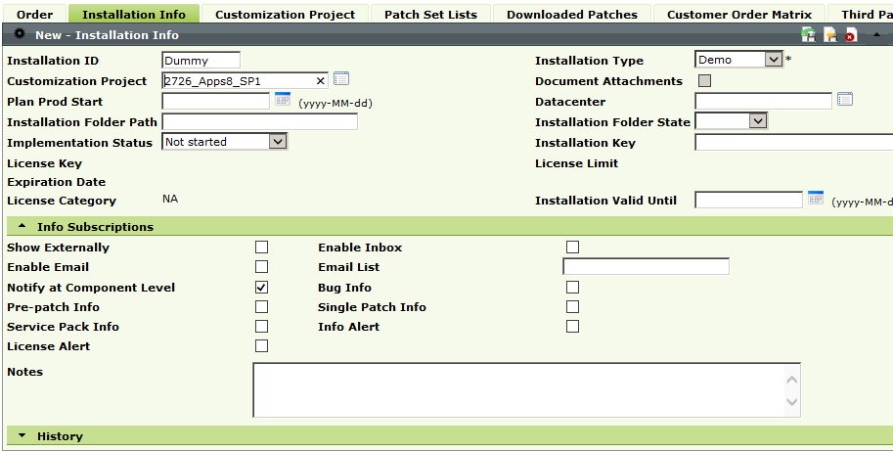

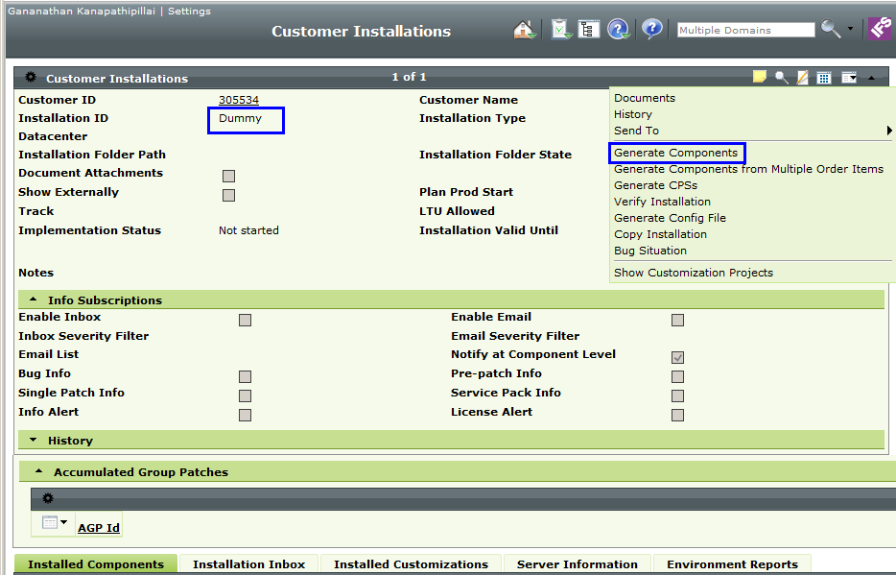

On the following screen, for the Regional Market you should only add LUK and MEE. Please note everything else has to go in as Harvest, so shouldn't be in the installation unless there are licensing considerations, eg. WADACO, MWO etc, but then the extension should be a known one.

If you are unsure, please talk to the TPM about this.

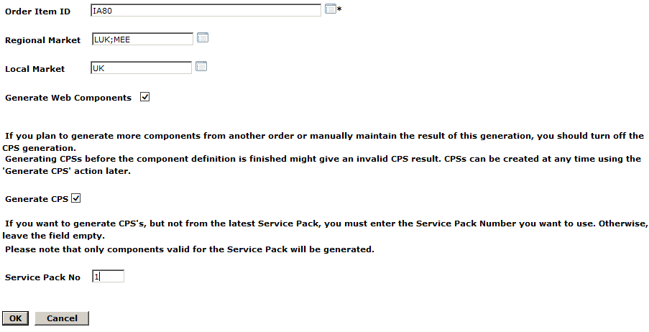

Once this is verified please delete the dummy installation.

## Adding components to internal customer installations:

You should add the new components to the internal customer installations as follows,

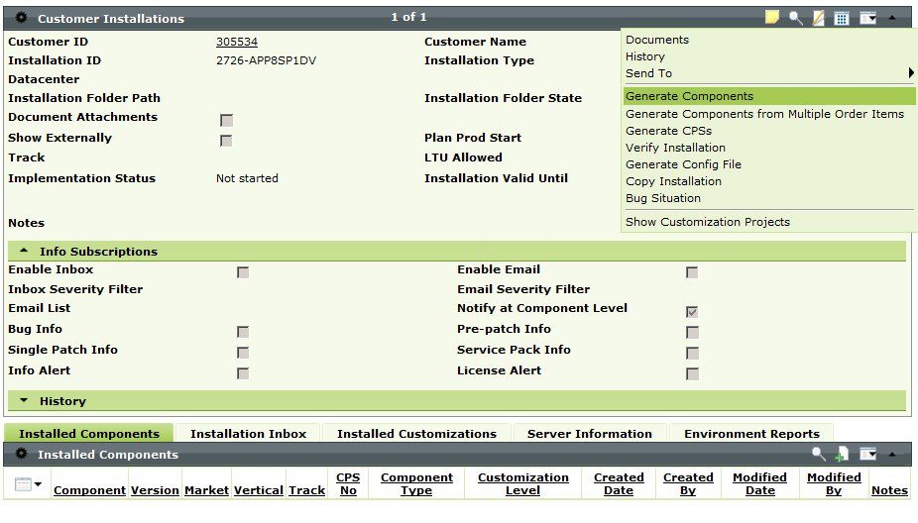



# Generate .cifx file

You should generate the .cifx files as follows,

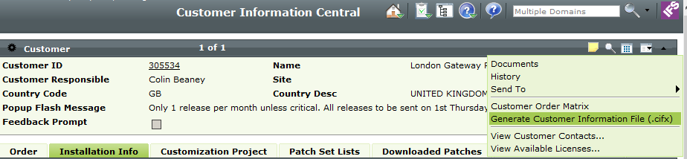

Note, in the .cifx file you only need the DEV installation information. Remove information related to other installations from the file.

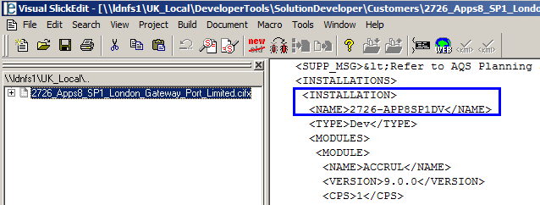

Replace the previous .cifx file with the new one in the following location.

\\ldnfs1\UK_Local\DeveloperTools\SolutionDeveloper\Customers

# Generate Config File

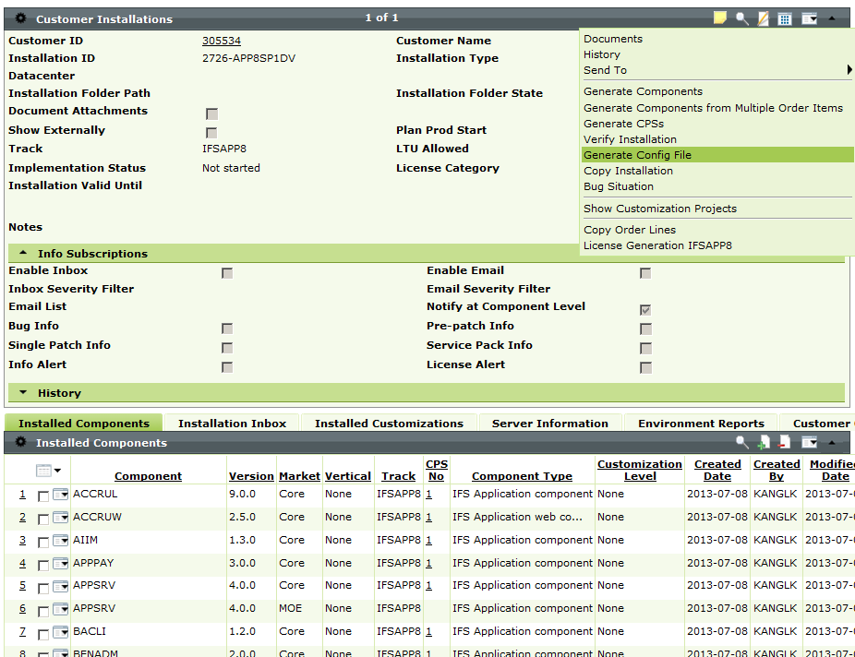

Copy the required modules (which need to be added) and create a txt file

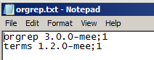

# Fetch the required files

Open the config builder

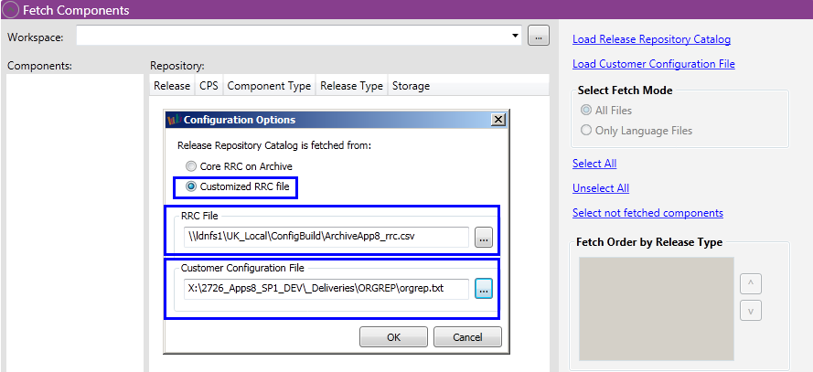

Select the work space with a folder to fetch the files

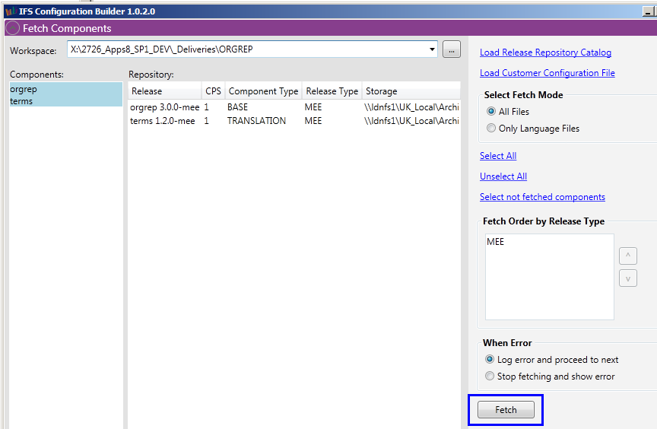

Fetch the files to build

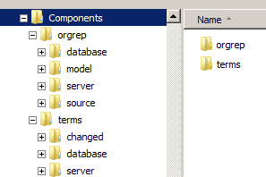

# Remove unnecessary lng and trs files

Before doing the build you should remove all the unnecessary lng and trs files

For example, With the ‘order’ component, the following .trs files are not required for most UK customers.

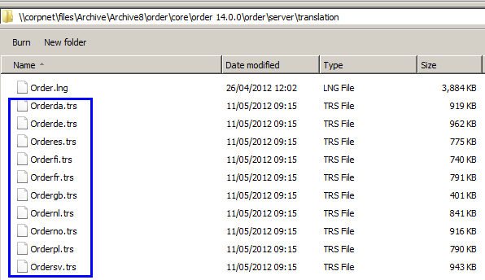

Note: It is worth checking this with the relevant TPM. Some UK customers are using different languages. In such cases you should include those .trs files in the build.

This is also applicable to the TERMS component,

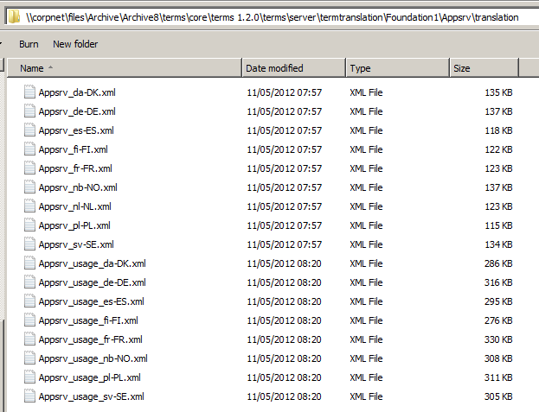

# eBOD information

In order to add an entry in eBOD we could create a new LCS case for this task or we could associate this with a prerequisite LCS case.

Example, for one of our customers we had to merge CIS vap, but ORGREP, which is one of the mandatory components, was not added in the initial build, so to add the ORGREP component, created a dummy text file and checked it in to harvest as follows,

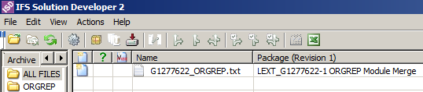

In this text file we could add some text as follows,

*Added the following modules*

*orgrep 3.0.0-mee;1*

*terms 1.2.0-mee;1*

**Customisation handover:**

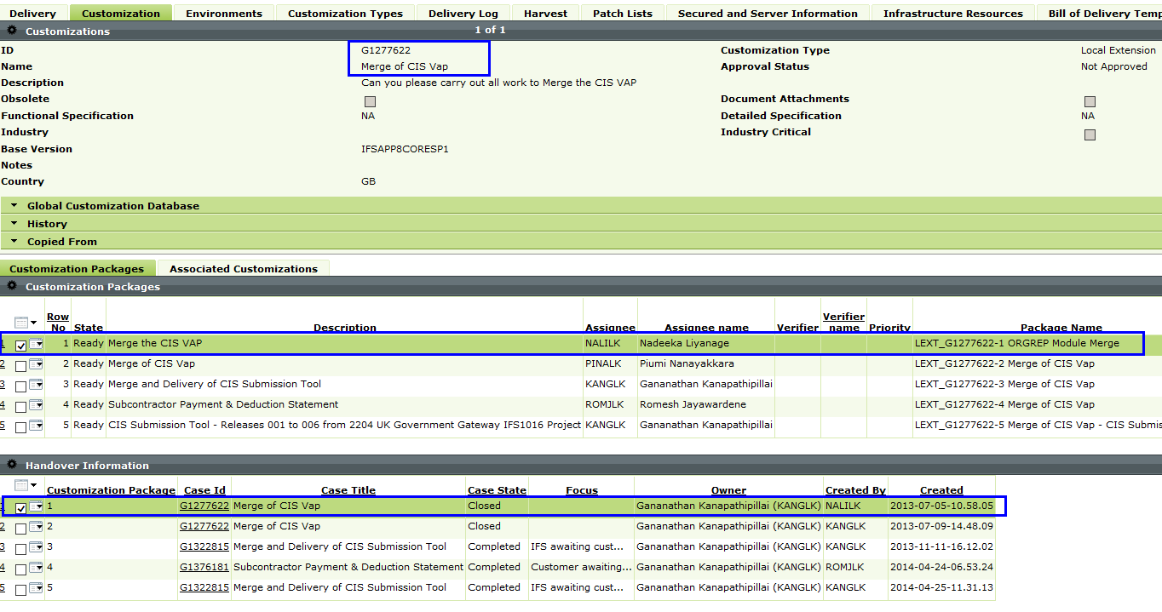

# Applying relavant bug corrections

You should remember to add any bug corrections (relevant to these new components) that had already been delivered to the customer with Local Patch Set (LPS) or as normal support patches (without these components).

This should go in a separate package, so for instance if you need to add a new bug correction line that came from the LPS you should create a new/separate harvest package against the LPS. Same would go for any individual patches that support have done, if they need an additional component line we have to create a new harvest package against the case where the initial corrections was done.

Note: Currently Krister is in the process of creating a Quick Report in order to identify these bug ids. Once it is finalised, this document will be updated with the information. In the meantime, either Krister or Hugh should be able to help you to identify the required bug ids.

Consider the following example,

Bug Id 115015 is currently included in LPS. Since in the initial customer build ORGREP component was not there, this was not applied to the customer with the initial LPS merge.

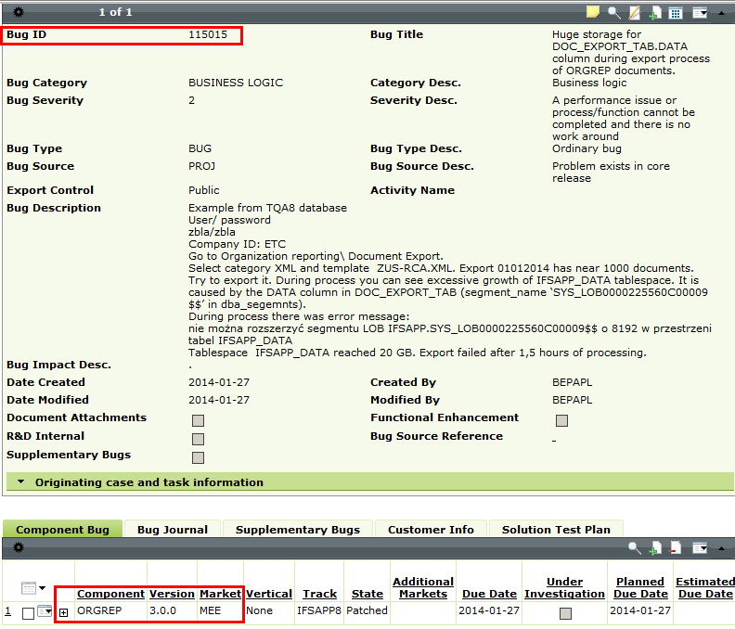

This bug was then merged while adding ORGREP module to the customer.

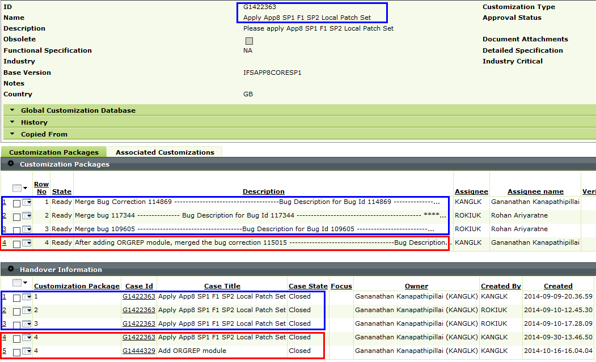

The parts highlighted in Blue are related to the initial LPS merge. The parts highlighted in Red are related to the ORGREP module. Please note in this example we didn’t create a dummy text file for eBOD. Since we had a missed bug correction related to the ORGREP component, we utilised it to achieve the eBOD requirement. That’s why here there are two handovers for the same package.

# Build and Install components

Add this customisation package to a dummy delivery. Generate ‘Harvest Extractor File’ for this delivery and save the .hewx file. Open the .hewx file and download the files from harvest (either the dummy file or the required patches etc.).

Then copy the contents of your fetched components from config builder over to the ISD download folder 'Revision1' making sure you don’t overwrite any existing files as these would most likely be later files from patches etc.

Consider the following example for ORGREP and TERMS components

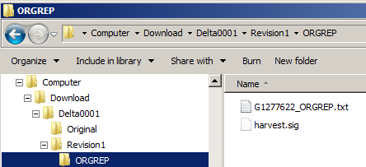

Copy the fetched ORGREP and TERMs components files and paste it inside the download folder, Download -> Detla0001 -> Revision1

**Copy from**

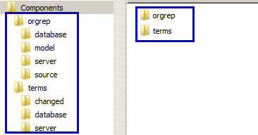

**Paste to**

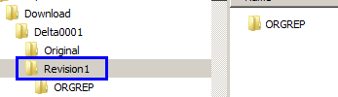

Then build the delivery the way you build any other standard delivery.

After successful compilation, install the delivery as normal.

Note : Apps 9 - install.tem file is not updated correctly with relevant .cre files entries

In the above build approach, in Apps 9 track, relevant .cre files (which are generated as part of the build) entries are missing in install.tem file. Need to modify the install.tem file correctly as follows before deploying the changes.

